There Is No Neutral

If NGOs think they can claim neutrality in Afghanistan, they're fooling themselves.

BY NADIA SCHADLOW | MARCH 16, 2011
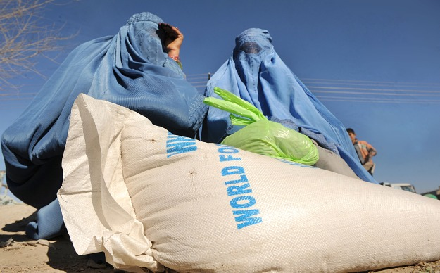
Clear. Hold. Build. These are the unquestioned ABCs of the counterinsurgency strategy that won the war in Iraq and now hold the hope for delivering victory in Afghanistan. Clear and hold are military operations, but "build" is increasingly the purview of the development world, which considers the notion of choosing sides in a conflict anathema. Yet as U.S. troops eventually draw down in Afghanistan, the work of development professionals -- the building -- will only become more important in securing U.S. war aims.
No one denies that NGOs accomplish vital work in some of the most dangerous places on Earth, but their commitment to nonaligned status suggests that most believe that tasks focused on improving human lives can somehow be apolitical. This perspective overlooks the political and cultural beliefs that cause harm to innocents in the first place. And though providers of humanitarian aid would like to operate in a "neutral space," there is no such location in the contested battlegrounds of an insurgency.
While the United States and its allies go to great lengths to respect the "neutral" space desired by NGOs, their enemies do not. Insurgent organizations often seek to gain control of these spaces through intimidation and coercion of the population, which allows them to operate with impunity from such areas. So-called neutral spaces, therefore, often make it harder to fight brutal enemies such as the Taliban. And support that NGOs provide to these areas can often be diverted to strengthen the enemy.
Examples of NGOs proclaiming their neutrality are legion. Doctors Without Borders states that it is neutral and does not take sides in armed conflicts. InterAction, an umbrella group of more than 165 organizations, affirms that its members are "not acting as an instrument of government foreign policy." And the International Federation of Red Cross and Red Crescent Societies, another very large umbrella group, explains that it is "essential to provide neutral and impartial assistance to all populations."
Many NGOs active in Afghanistan have also refused to endorse the international coalition's political priorities. The director of the Afghanistan NGO Safety Office advised its members not to engage in civil-military coordination activities because NGOs had "nothing to gain and much to lose" by interacting with the International Security Assistance Force (ISAF), which is only interested in "leveraging advantage from your activities."
The international community continues to funnel tremendous amounts of resources to development groups in Afghanistan, even while they refuse to endorse its political priorities. Last December, the United Nations in Afghanistan launched an appeal for $678 million for humanitarian aid, noting that NGOs would play a large role in reducing the suffering of the Afghan people. This assistance would be provided, stated the U.N. coordinator there, "according to the core tenets of humanity, impartiality and neutrality."
In official documents, the United States and many of its allies tend to accept and endorse these positions of neutrality. U.N. guidelines affirm that there should be a "clear distinction" between humanitarian actors and the military so that NGOs can function in a neutral operating environment. And though Washington applies enormous resources to working on the political and economic reconstruction of Afghanistan, it also warns provincial reconstruction teams (PRTs) that humanitarian assistance "must not be used for the purpose of political gain, relationship building or 'winning hearts and minds'." Yet the ability to initiate and sustain successful reconstruction efforts requires developing good relationships among the people. And the rationale for the PRTs is nested within a broader set of political goals for Afghanistan -- goals not shared by the Taliban.
Neutrality not only requires turning a blind eye to hostile organizations, but also risks enriching and strengthening bad actors physically and psychologically. Neutral assistance provided in areas that bad actors control is often diverted to armed groups, which also seek to take credit for any assistance that does make it to the population.
The very fact that an aid organization can travel safely in a contested province often means that insurgents have calculated that it is in their interest to allow the organization safe passage. The fact that an NGO-built school remains standing -- while an ISAF school is destroyed -- is likewise because insurgents have made a political calculation. NGOs suggest that their neutrality means that they are not participants in the conflict, but this is simply not the case. Indeed, a report by eight NGOs operating in Afghanistan affirms that insurgents deliberately target ISAF-built schools in order to reduce support for the United States and its allies.
Insurgents measure their success in terms of their ability to operate among the people -- even if, as is often the case, they are doing so using intimidation and coercion. In a counterinsurgency campaign, it is impossible to ignore that improving the daily lives of people -- by insulating them from fear, improving their security, building schools, aiding the local economy -- will also affect political outcomes. This is the very nature of counterinsurgency warfare.
While the U.S. Army and Marine Corps have developed new operational concepts in order to operate in these contested political landscapes, the NGO sector has, for the most part, not undergone such a reassessment. By eschewing the development of a political strategy to underpin the provision of aid and assistance, its effects will likely be short-lived. By not empowering good actors, neutral NGOs make it harder to make the most of resources at hand.
This issue will only grow in importance. The White House's December review of U.S. strategy in Afghanistan confirmed the importance of building "sufficient Afghan capacity," improving civil-military integration, and continuing support for Afghanistan's development. A critical component in the United States' ability to meet these objectives is the work of NGOs. The State Department's first-ever Quadrennial Diplomacy and Development Review also reaffirmed the importance of NGOs, noting that they will play an "ever-greater role" in international affairs.
In Afghanistan, the United States has relied on an ad hoc hodgepodge of contractors, civil-military units, and NGOs to perform the reconstruction work essential to defeating the Taliban. But it's high time that U.S. policymakers ask themselves the difficult question of why the Pentagon and the State Department use "neutral" parties -- actors who by their own statements do not openly endorse the goals the United States is striving for -- to deliver services that are key to winning the war.
Clearly, aid workers should be lauded for the great personal sacrifices they make. They show extraordinary courage and commitment. Many have given their lives. But the inherent decency of a profession should not absolve it from scrutiny, nor shield it from debate.

