The Hohenzollerns
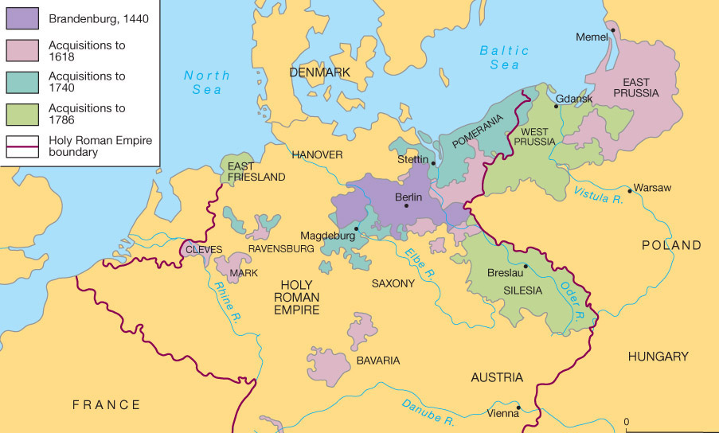The Growth of Prussia
Frederick William, the Great Elector (1640-1688)
Guided country through last years of 30-Years War
Reorganized armies of state into one national force
Improved tax system
Encouraged agriculture, industry, and infrastructure improvement
Imitated Louis XIV lavish court
Frederic I (1688-1713)
(state now known as Prussia- HRE named F-I King of Prussia for support in War Sp. Succession)
Got rid of much of the luxury of court
Doubled size of army- made most efficient fighting force in Europe (all TALL)
Created efficient government bureaucracy
Encouraged trade and industry
Compulsory education
Frederick William I (1713-1740)
Killed son’s friend in front of him to toughen him
Signed Pragmatic Sanction
Frederick (II) the Great (1740-1786)
Played flute
First 23 years of reign- WAR
Invaded Silesia, didn’t recognize Maria Theresa- sparked War of Austrian Succession (1740-48)
(didn’t sign P.S.)
Diplomatic Revolution (1756) Realigned with GB
Realignment led to 7-Years War (1756-63)
ALL of Europe & global conflict
Prussia pushed to brink of defeat- held together by Frederick the Great
also death of bitter enemy, Russia’s Catherine the Great
First Partition of Poland (1722) Linked Prussia and East Prussia
Next 23 years- Internal administration & organization
Expanded and improved education system
Legal and court reforms
Encouraged trade and manufacturing
Committed to religious tolerance
No interest in granting self-government to national or ethnic minorities
Left Prussia as a rival of Austria of control of Germany and a first-rate European Power

