Fair Trade v. Free Trade
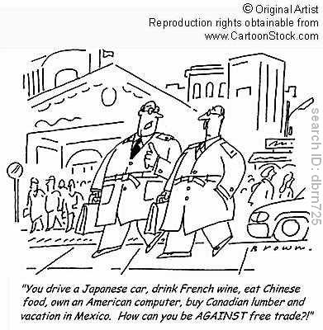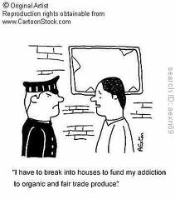

One of the issues that arises in the world of globalization is the debate between those who believe that the best way for international transactions to work is through “free trade” and those who argue that there must be some form of protections for certain sectors of the economy in the form of “fair trade.” Your job is as follows:

- Come up with a working definition of both “free trade” and “fair trade.” Be sure that you have consulted several reputable sources to make sure that you fully understand both concepts.
- Articulate what the conflict is between the two concepts. Are they mutually exclusive? (ie. You can’t have a system that is both “free” and “fair” or yes, they can live side by side).
- Identify what groups, organizations and/or agreements have been developed to support both free trade and fair trade.
- Take a stand: which do you think provides the best system of trade for the international community?
- Create a poster, infographic, power point or Prezi that explains your research and position on this topic.

You will work in groups of three and will be given two class periods in the library to do your research. The finished project will be due on Wednesday, September 21 and we will present your findings on Wednesday/Thursday. This will be graded on a scale of 100 as follows and counts as a major grade (60%):

Written project (100 points):
Comprehensiveness of research (50 points)
Creativeness of poster, infographic, power point or Prezi (20 points)
Persuasiveness of argument (20 points)
Attention to detail (spelling, grammar, neatness, balance, color, background, images….) (10 points)

Oral Presentation (50 pts):

All group members contribute equally (20 points)
Everyone in group can explain all aspects of the project (10 points)
Clear voices, enunciation, pronunciation (10 pts)
Professional demeanor (no laughing, giggling etc..)(5pts)
No errors in information (5 pts)

