Ancient China Board Game
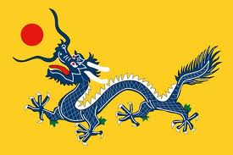
Students will research, design, and create a game board based on information learned in our study of Ancient China. The game will require students to identify the key questions, difficult issues, essential understandings, and important concepts of the unit. After completing the project, students will write evaluations of the group process and of other games created in the class.
Instructions:
1. Design and make a board game. Use cardboard, poster board, construction paper, legal sized file folders or an old board game. Decorate the board with art that relates to Ancient China. You must also create and provide any game pieces, dice, spinner or other device that is necessary to play the game.
2. Make up questions that relate to Ancient China from approximately 2600 BC to 500 AD. The questions should be typed on a word document, then printed and glued onto 3” X 5” index cards cut in half. The questions can be in any format (fill in the blank, multiple choice, true or false, simple answer). Each student in your group must come up with 20 different questions. Questions should evenly cover all aspects of Ancient Chinese civilization and be challenging, but not overly difficult.
3. You must prepare an answer sheet for all of your questions. All answers must be correct!
4. Make up and write the objective of the game and rules of play. This document will be given to each group that plays your game.
5. Play the game through once. Adjust (correct) parts of your game as needed.
6. Exchange and play another group’s game.
7. Complete an evaluation form for each game played.
Things to consider:
OBJECT OF THE GAME: Decide how the game is won.
EQUIPMENT: What is necessary to play the game. (Game board, die, cards, etc.)
SET UP: How do you set up the board before play? How do you decide who takes the first turn?
RULES OF PLAY: How does a player move around the board? Are there penalties for wrong answers? How many players can play?

